Lifecycle Policy of S3
- Create a bucket
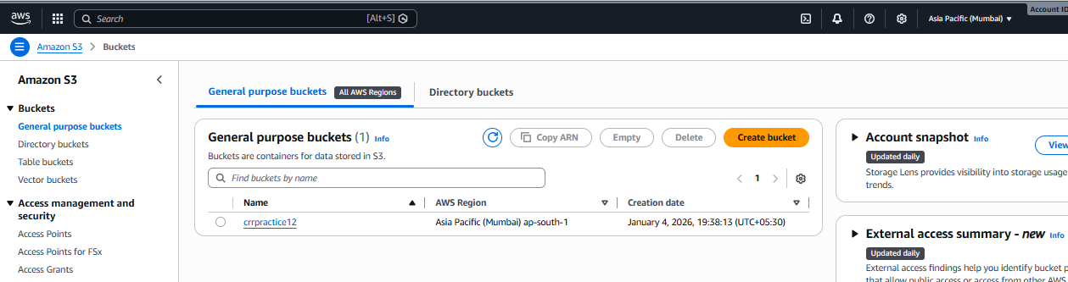
Inside the bucket please create a lifecycle policy in the management section
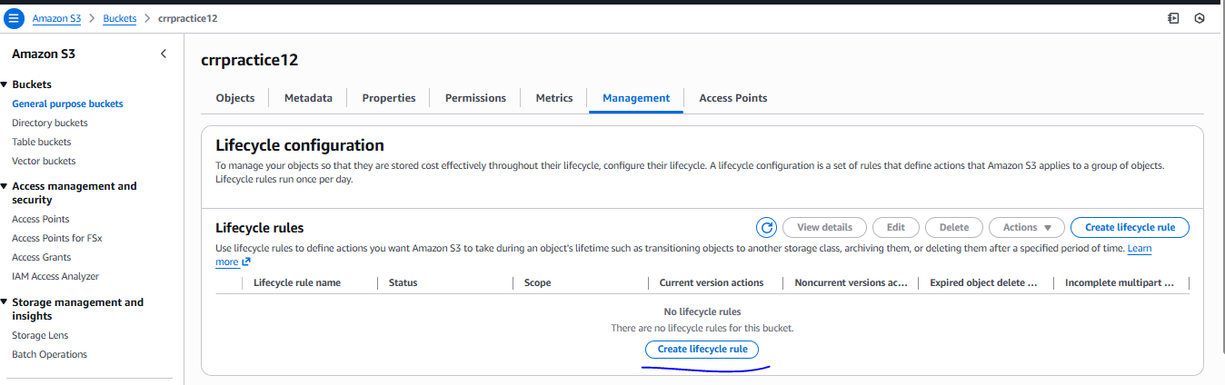
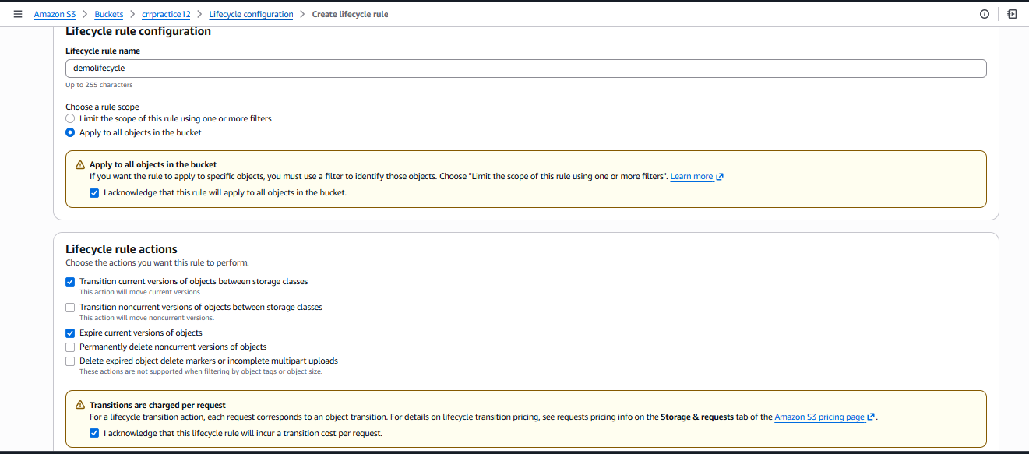
If we enable expire current version of object automatically Expire current versions of objects option enabled
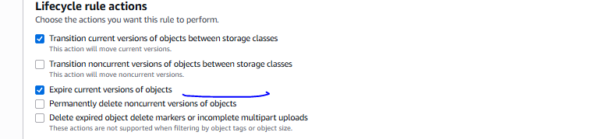
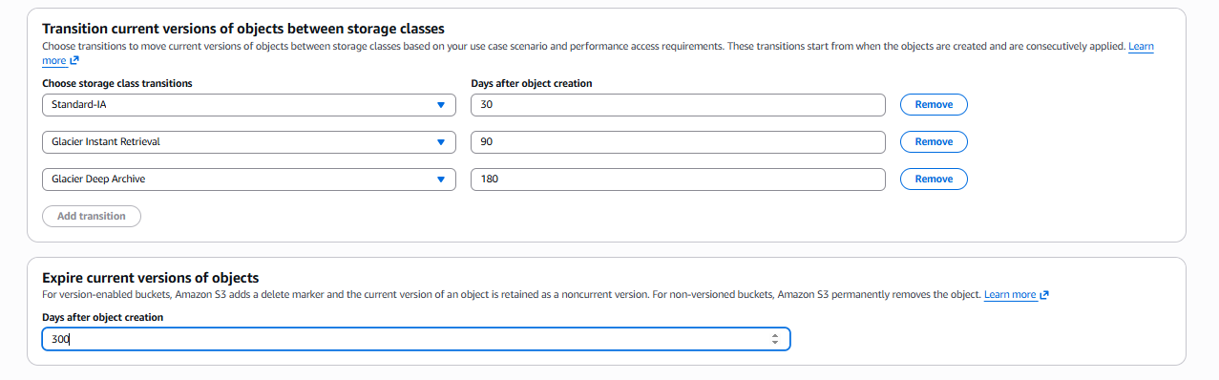
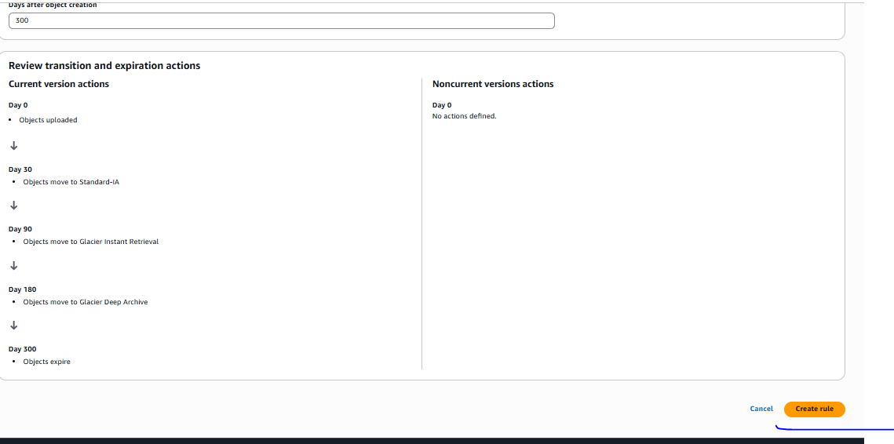

Lifecycle Created
